Alfred Hitchcock’s Psycho (1960) and North by Northwest (1959), exhibit the common artistic style and themes prevalent in many of his movies, yet still there is distinct uniqueness in each film. Hitchcock, known as the Master of Suspense, utilized many methods of engaging the audience in his movies. His most noteworthy in these two films were his use of suspense, synchronization and timing of musical score, and human sexuality.
Alfred Hitchcock commonly teamed up with composer Bernard Herrmann. Many films Hitchcock directed are celebrated for their musical scores and Herrmann aided in his success. Hitchcock wanted the music to comply with his sparse, dark black and white film with a sparse and dark score. What he got was an immediate success; the infamous Psycho shower scene has haunted people ever since the movie’s debut in 1960 and the music is noted as the most widely recognized score of all time. 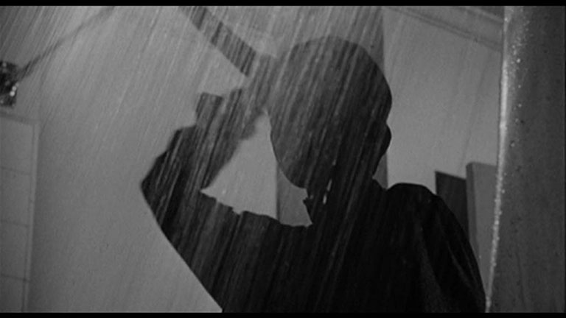
The “screaming strings” that went along with this particular scene has been re-used many times in countless movies to evoke fear and suspense in the plot. Hitchcock uses dreary weather in the eerie night time scene when Marion drives to the hotel. Herrmann helps to accommodate Hitchcock’s idea by using music that creates high tension from the viewer. The use of high pitched repetitive music establishes a mood of elevated tension and uncertainty. Both these emotions are felt by the characters in the film as well as the audience. Herrmann and Hitchcock also work together in North by Northwest, in which the score is also easily identifiable. Since it is a thrilling mystery film, the music is compelling and energetic. It keeps the audience absorbed in what the next scene has in store. Heightened flow of music obliges the audience to commit to increased focus and attention because they know something of importance is imminent. Mellow music or no music at all establishes the mood that the audience can relax.
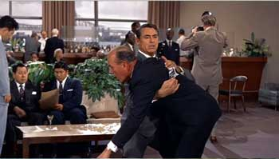
During the scene where the killing takes place at the UN, the music is very repetitive. This helps generate apprehension in the viewer. Music, if used correctly, can have a great effect on the audience in arousing certain emotional responses. Alfred Hitchcock used this inside knowledge as an advantage in the creation of his films.
During a time where sexuality was shunned not only in off-set but also on-set, Hitchcock serves as a pioneer for modern day cinema. Human sexuality was a risqué matter to deal with; one had to maneuver carefully around the subject in order to maintain public approval. Hitchcock displays Marion just in her under garments on numerous accounts.
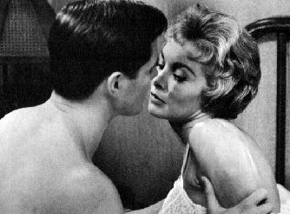
He also shows Norman Bates spying on her while she changed and got in the shower. This film displays hints of nudity as well. When Marion is being stabbed in the shower by the “mother”, the audience can see the outline of her nude body for a brief second behind the shower curtain. During these days there were various constraints that limited Alfred Hitchcock’s use of sexuality in his films, but he made the most of these limitations. Not only was Hitchcock one of the first in his field to incorporate sexuality in his films, he also was one of the first to use psychoanalysis of sexuality. Psychoanalysis became popular among American culture in the 1920’s. Hitchcock’s most memorable film that integrated the psychoanalysis of sexuality was Psycho. The Oedipus Complex from which Norman Bates suffered, created a problem for any young girl who came across his path. His intense attraction towards his mother made him feel threatened when she married Norman’s step father and it also made him feel guilty for any sexual feelings towards Marion (which is ultimately why he killed her). At the end of the movie, Dr. Fred Richmond provides the audience with psychoanalysis of Norman Bates. In North by Northwest Roger Thornhill and Eve Kendall display what may seem like nothing for viewers of today’s generation, but at the time the film was released the dialogue exhibited definite sexual innuendo. For example, Eve tells Roger, “I’m a big girl”. Roger replies, “Yea, in all the right places too”.
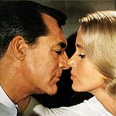
Hitchcock revealed to the public that "Our big problem...is trying to make the censors understand that the young people are much more sophisticated than they used to be". Audiences were ready for this type of explicit material; Hitchcock claimed that if he had not shown as much as he did in the movie Psycho and North by Northwest, then the films wouldn’t have had the tremendous success that they did. Working around the censorship laws proved to be difficult, but Hitchcock made sure that what he wanted to show in the film would be shown.
Alfred Hitchcock is commonly referred to as the Master of Suspense. He created movies that attracted the audiences attention not from the plot itself, but from the building up of the plot. Hitchcock once stated, “There is no terror in the bang, only in the anticipation of it”. He enjoyed making the audience think one thing was going to happen and then at the right moment, unveiling a secret or hidden truth about someone or something. Hitchcock frequently employed the Wrong Man Theory into his films. He would make the audience think one person was guilty and then they later find out that he or she was innocent. This element of suspense is one of the key factors that made his movies such a success. For example, in Psycho the audience thought for the majority of the movie that Norman Bates was a nice young man who had a mentally ill mother. The audience thinks that it is the mother who killed Marion and the Detective. It is only revealed later that Norman has dual personalities and his ‘mother’ side was the one that killed Marion and the Detective. In this movie, it is the audience that uncovers the mystery. In North by Northwest, it is the main character Roger Thornhill that has to solve the mystery and prove his innocence. The audience already knows that he is being framed as the man Kaplan; but there is another twist Hitchcock throws in. Kaplan doesn’t actually exist. The suspense that builds up to this element of surprise is what has kept audiences raving about his films for decades. Hitchcock also utilizes various camera techniques to evoke suspense. When a critical moment in the scene arrives, Hitchcock closes in on the point of focus whether it is a character or a specific object. For example, in a scene during Psycho the camera constantly focuses on the money on the bed. This shows that the money is of some importance to the film and makes the viewer notice the object more. In North by Northwest there is a scene where Roger and Eve are both clinging to one of the president’s faces on Mt. Rushmore. Hitchcock uses a wider framed shot to emphasize the great size of Mt. Rushmore in contrast to Roger and Eve’s bodies.
This reveals the magnitude of the situation. It shows how great the distance is if they fall off the mountain so it creates suspense for the audience. They know that the two main character’s lives are at stake.
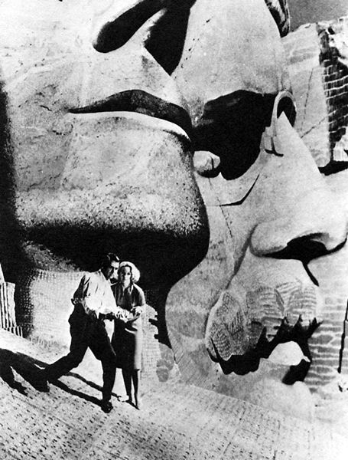
Hitchcock is by no doubt a directorial genius in his creation of so many popular films in his lifetime. His use of recurring styles and themes are what has helped make him so widely acclaimed and praised. The films Psycho and North by Northwest are worth viewing not only because he utilized many of his famous styles and themes, but also because there are definite commonalities in the film that allows for comparison. His use of suspense, synchronization and timing of musical score, and human sexuality has established a framework for which he has constructed his success in the films Psycho and North by Northwest.

Films Watched:
- Psycho. DVD. Dir. Alfred Hitchcock. Universal. 1960.
2) North by Northwest. DVD. Dir. Alfred Hitchcock. Universal. 1959.

Websites Used:

http://www.film.queensu.ca/Critical/Sage.html

http://www.tcf.ua.edu/Classes/Jbutler/T112/HitchNxNW2.jpg

http://members.tripod.com/gillonj/alfredhitchcock/

http://faculty.cua.edu/johnsong/hitchcock/pages/psychoanalysis.html

http://hitchcock.tv/

http://www.mysterynet.com/hitchcock/

